|  |  |  |  |  |  |  |
| --- | --- | --- | --- | --- | --- | --- |
| Test Case ID | Asset | Feature | Environment | Test Case Description | Expected Result | 20 Sep |
| 9.1 | Customer Client | Sign in | Chrome | Successful Sign in | Display message for ‘Successful Sign In’ | Pass |
| 9.2 | Customer Client | Sign in | Chrome | Unsuccessful Sign in for incomplete form | Display message for ‘all fields are required*’ | Pass |
| 9.3 | Customer Client | Sign in | Chrome | Unsuccessful Sign in for username already exists | Display message for ‘All fields are required*’ | Pass |
| 9.4 | Customer Client | Sign in | Chrome | Unsuccessful Sign in for password too short | Display message for ‘Password should have at least 6 characters’ | Pass |
| 9.5 | Customer Client | Sign in | Chrome | Unsuccessful Sign in for username too short | Display message for ‘Username should have at least 4 characters  ’ | Pass |
| 8.1 | Customer Client | Login | Chrome | Successful Login |  |  |
| 8.2 | Customer Client | Login | Chrome | Unsuccessful Login | Display message for ‘incorrect username or password ’ | Pass |
| 7.1 | Customer Client | Edit profile | Chrome | Directed to edit view from profile view | Directed to edit view from profile view | pass |
| 7.2 | Customer Client | Edit profile | Chrome | Direct to profile page. Update successful with username, address and phone updated | Direct to profile page. Update successful with username, address and phone updated | pass |
| 16.1 | Customer Client | Make booking | Chrome |  |  |  |

9.1

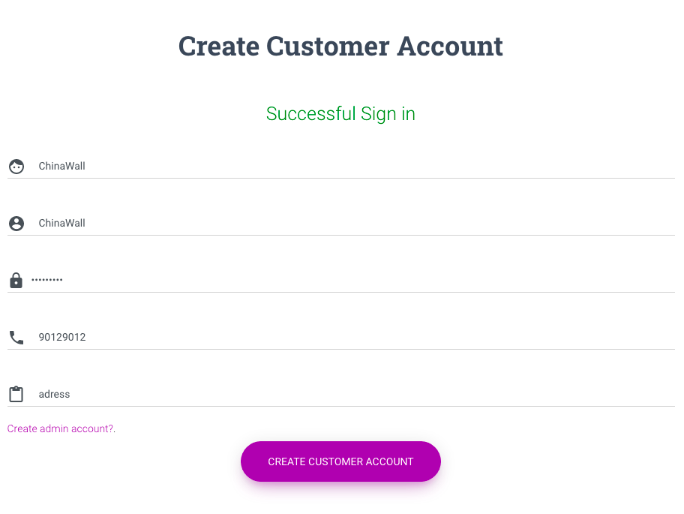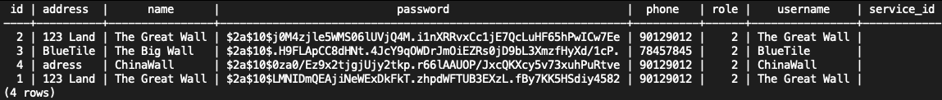

9.2

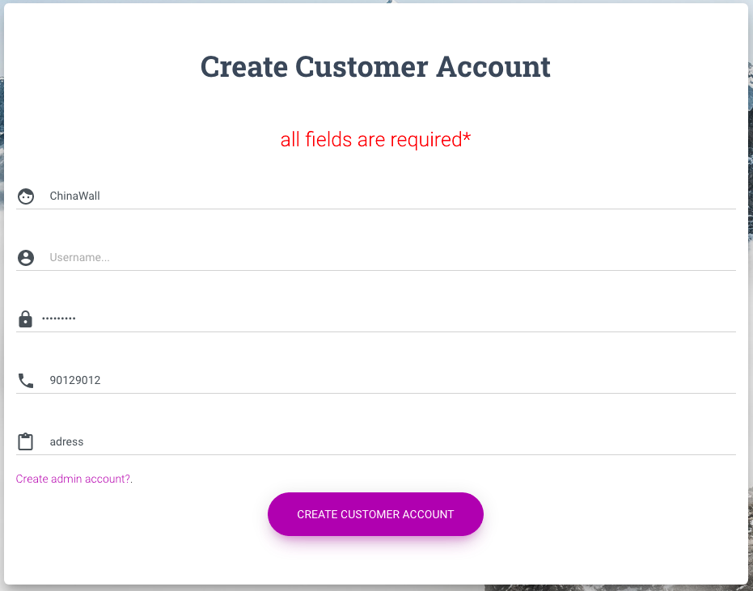

9.3

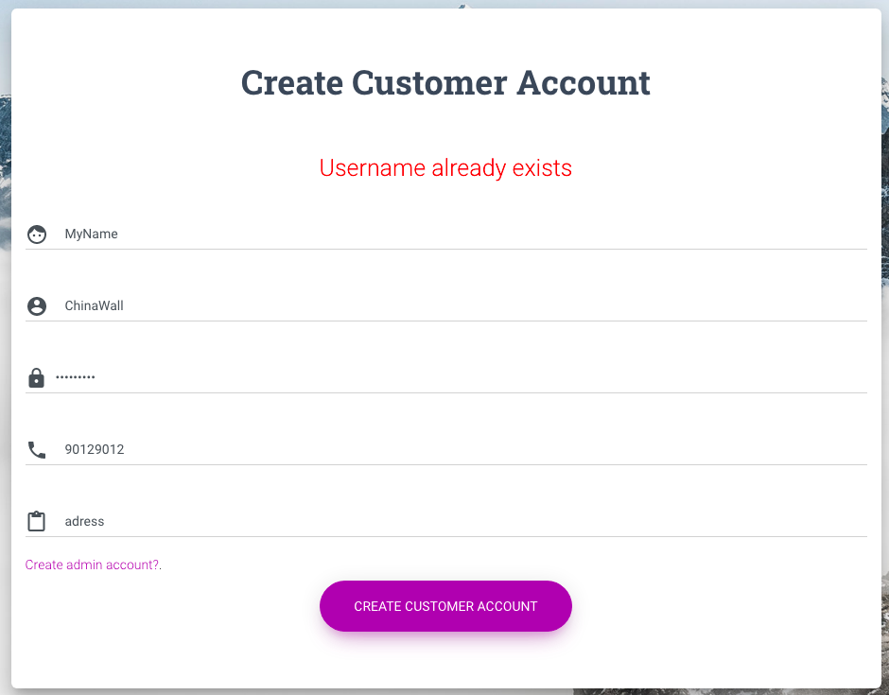

9.4

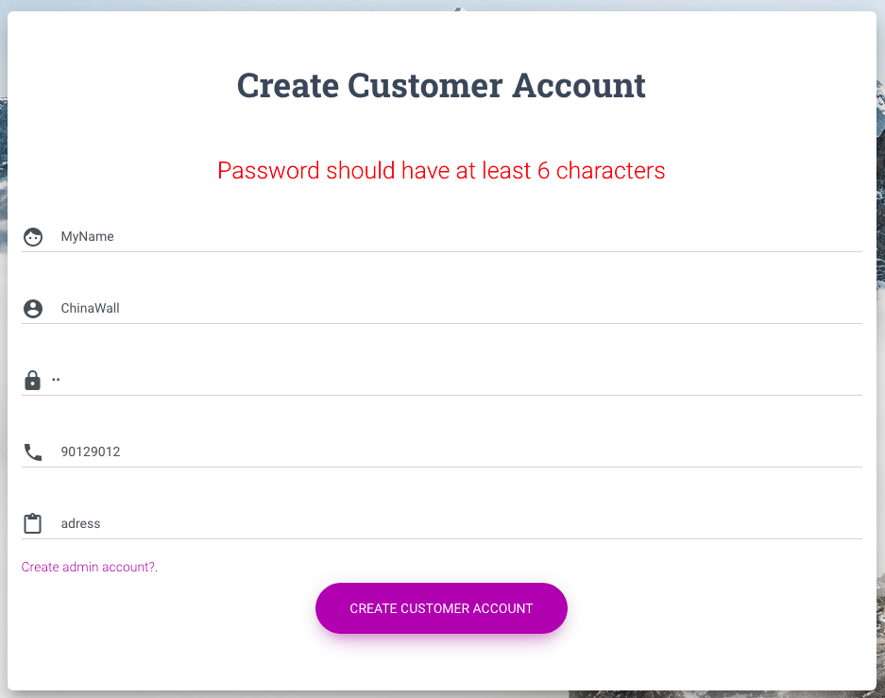

9.5

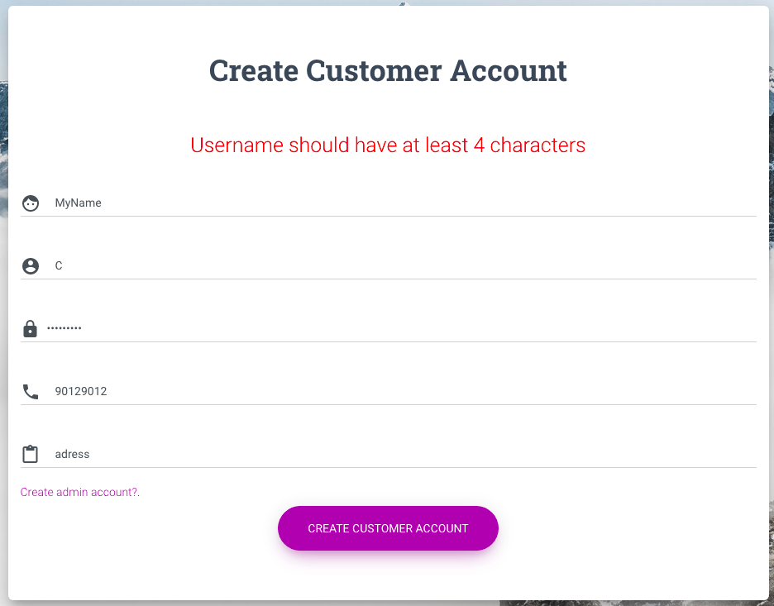

8.2

